**FORM LAYOUTS OF JOB ALLOCATION APPLICATION**

(a) Main **Login window** of Job Allocation application :-

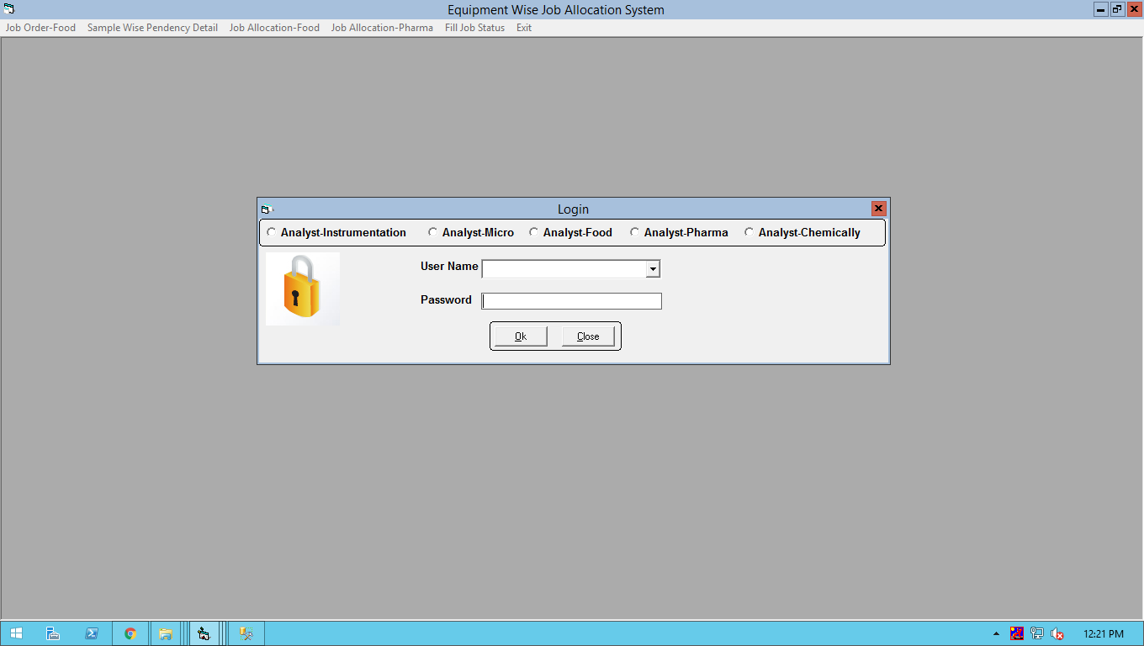

(b) **Job Allocation Window :-** This window displays the instrument wise parameter pendency detail in the instrument section for the allocation to the analyst. This window displays already allocated parameter detail also.

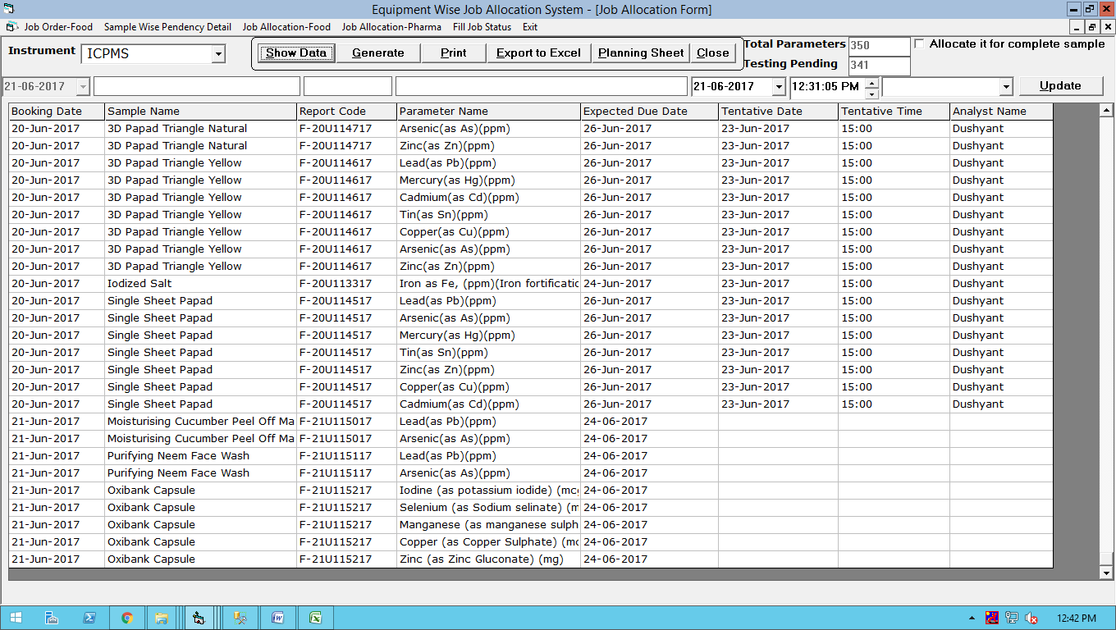

(c) To Update Status Analyst wise on the completion of Job :-

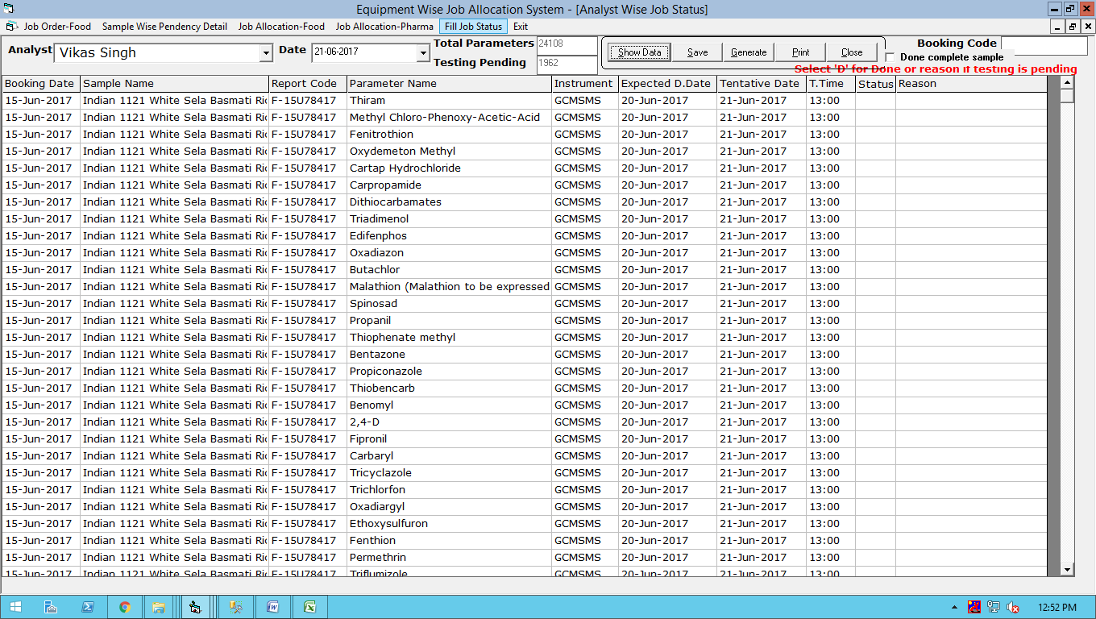

**(d) To Take print out of Job Sheet & amendment in job sheet** :- Job order is given by booking person. The print out of job sheet is taken in the corresponding section by the job allocator after doing the correction in method names , limits and instrument name if it is required**.**

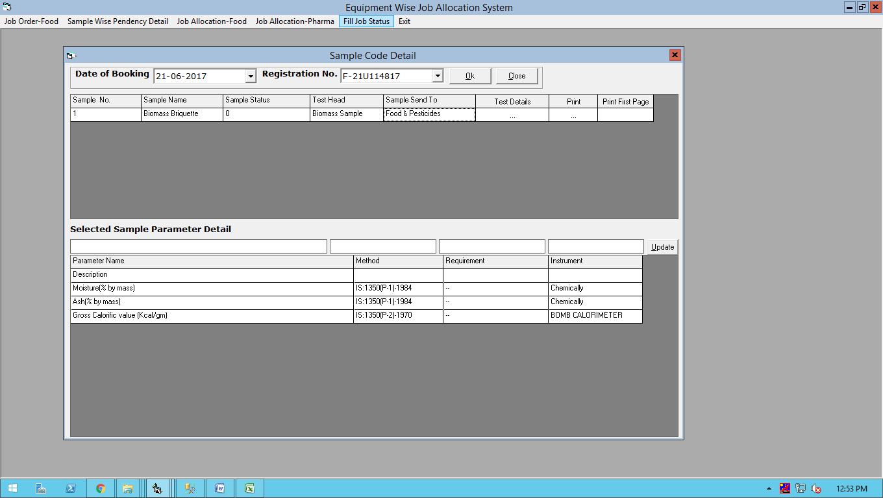

**(e) Print Screen of Job Sheet:-**

